PUSHING IMAGE FROM LOCAL VM TO DOCKER HUB.
NAME: SRIDHAR S
ROLL – NO: 23ISR055
Step 1: Creating a Docker Hub Account
This step involves registering on Docker Hub to store and share container images.
A Docker Hub account provides a remote repository for images that can be accessed from any system.
Action:Visit: https://hub.docker.com → Click Sign Up → Complete registration.
Step 2: Logging into Docker Hub from Local VM
This step authenticates your local Docker client with Docker Hub to allow image uploads.
Command to Run:
- docker login -u username
- 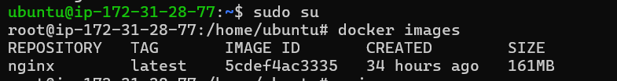

Step 3: Viewing and Tagging Docker Images
This step displays the locally available Docker images and assigns a new tag for Docker Hub upload.
Commands to Run:
- docker images
- docker tag mynginx<dockerhub-username>/mynginx:latest
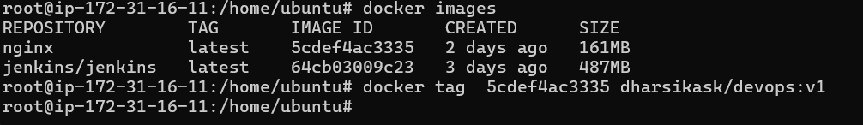

Step 4: Pushing the Docker Image to Docker Hub
This step uploads the tagged Docker image from the local VM to your Docker Hub repository.After pushing, the image becomes accessible from any system using Docker.
Command to Run:
- docker push <dockerhub-username>/mynginx:latest
- 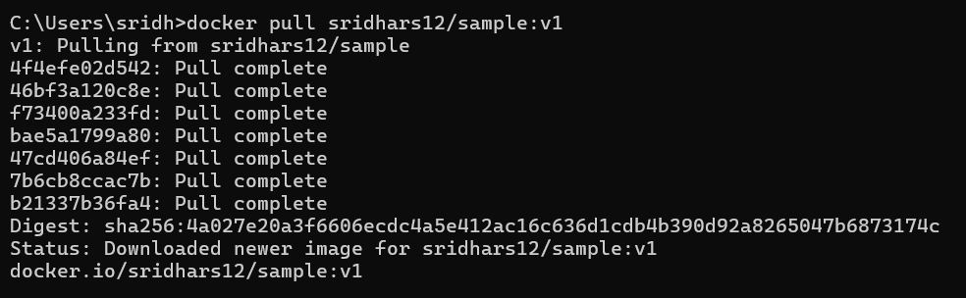

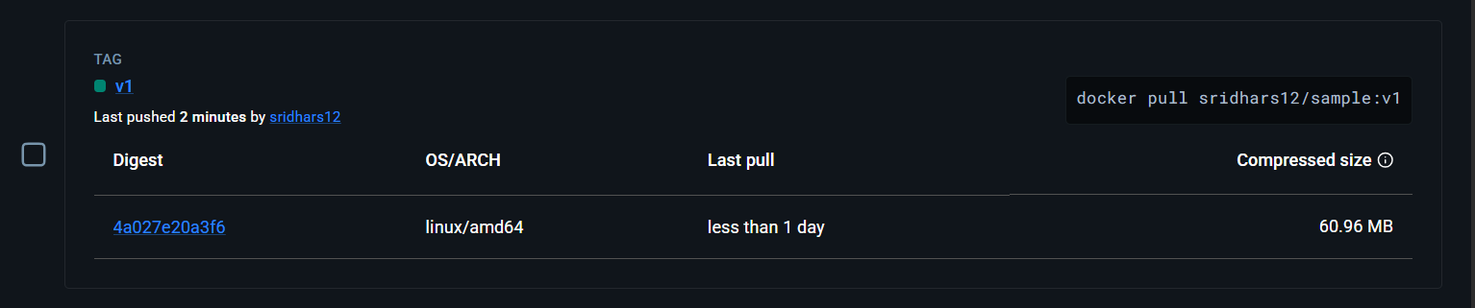

Step 5: Logging into Docker and Pulling the Image
This step authenticates the local VM with Docker Hub and downloads the uploaded image.Pulling the image ensures the latest version is available locally for deployment.
Commands to Run:
- docker login
- docker pull <dockerhub-username>/mynginx:latest

